Resources & volunteer opportunities during COVID-19

Please note: We are doing our best to keep this as updated as possible. If you know of a community resource that is not currently on this list, please email us at: hoperesources@unlv.edu. If you know of a virtual volunteer opportunity that is not currently on this list, please email us at: serve@unlv.edu.

Table of Contents
Important UNLV Resources
General UNLV Resources
Financial Support Resources
Academic Support Resources
Community Resources & Guides
General
Healthcare Resources for Undocumented Folx
Mental Health Resources
Food Distribution Resources
Organizations Supporting Folx Experiencing Homelessness
Virtual Volunteer Opportunities
Las Vegas Opportunities
Other Opportunities

Important UNLV Resources

General UNLV Resources
UNLV Coronavirus Updates - https://www.unlv.edu/coronavirus
- The primary page for all updates related to COVID-19 and UNLV.
- Information for students includes parking refunds, meal plan refunds, tuition payment plans, Spring 2020 course grading, withdrawal deadline, online instruction, library online support, disability resource center, academic success center, bookstore update

UNLV Food Pantry - https://www.unlv.edu/integratedhealth/food-pantry
- The UNLV Food Pantry is open and available to anyone with an NSHE ID (students, staff, faculty)

Financial Support Resources
The Intersection - The Intersection
- NOTE: For a limited time, emergency funding in the amount of $100.00 will be available to students adversely impacted by circumstances related to COVID-19.
  - LIMIT: $100.00

Jean Nidetch CARE Center Survivor Care Fund - https://www.unlv.edu/womenscenter/support
- Students who would normally be eligible for the Jean Nidetch CARE Center Care Fund may still be referred to JNCC.

Financial Aid Emergency Loans - https://www.unlv.edu/finaid/loans/emergency
- Amount is limited to $650/semester with a $20 service fee.
- Only one loan may be issued per semester.
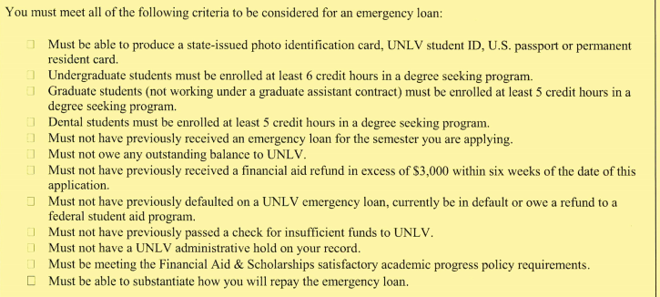

UNLV College of Liberal Arts Student Assistance Funding for Emergency Relief (SAFER) Program
- Seeks to provide emergency grants as well as support and resource connection for students
- Assists low- or moderate-income College of Liberal Arts students (undergraduate and graduate)
- Meant for educational purposes only: tuition, textbooks, wifi, etc.

UNLV Graduate College - https://www.unlv.edu/graduatecollege
- Emergency Retention Awards for Graduate Students
- Loans for Graduate Assistants
- Contact the Graduate College, 702-895-4273

Please note: Individual UNLV Colleges may have funds available on a case by case basis.

S.O.S. Emergency Relief Fund - https://www.unlv.edu/campuslife/sos-fund
- Funding is limited to once per academic year with a maximum award of $500

Academic Support Resources
UNLV Academic Advising - https://www.unlv.edu/advising
- It is very important to communicate clearly with your academic advisor during this time.

Remote Learning Issues
If you are experiencing any issues in your remote learning, be sure to reach out early!
- Email is best as students may lose access through other electronic means (i.e. Webcampus once semester is complete)
- Be sure to put your concerns or requests for leniency in writing (via email) to your instructor. If you do not receive a response or think the instructor response is not reasonable, you can forward the concern along.
  - It is recommended that students use the below chain if you are not seeing any progress with your identified concerns:
1. Instructor
2. Department chair
3. Dean
4. Dr. Javier Rodriguez, Vice Provost for Academic Programs
- Be as specific as possible with your issues and/or concerns
- Document, document, document! all information and correspondence
- Remember: Each of the steps will take time.

CSUN Digital Suggestion Box – CSUN Suggestion Box Form
You may share your concerns with CSUN through their Digital Suggestion Box as another method for communicating issues you are facing or concerns you have as you and other students navigate this transition

Community Resources & Guides

General

Animal Foundation- Pet Surrender Prevention Services
- Program helps pet owners in need of assistance in many ways in order to allow them to keep their furry family members including pet food, opportunities to assist with medical care, and more.

Battle Born Progress Resource Guide - Battle Born Progress Resource Guide
- Lists a variety of resources available in Southern Nevada and across the state, including news updates, childcare & education resources, food resources available for a range of community members, and more.
- en Español

UNLV Testing for COVID-19
- Must complete the Digital COVID-19 screening tool via phone first. If criteria is met, individuals can connect with the call center for more info and/or an appointment: (702) 583-4408
- News Story

Las Vegas Metro Police #StayHomeForNevada Toolkit - Toolkit Link

Latinx Activism Guide (UNLV Student Diversity and Social Justice) - https://tinyurl.com/LatinxActivismGuide

Legal Aid of Southern Nevada - Financial/Legal Assistance Toolkit
  - The links to the Toolkit are at the bottom of their COVID-19 resource page – we linked to this main page so the link will function when their documents are updated.
  - Toolkit also available en Español

Nevada 211 - https://www.nevada211.org/
- Connects all individuals, families, and providers to essential health and human services information and resources.

Nevada Current Resource Guide - Nevada Current Resource Guide
- List of financial, housing, food, healthcare, safety, and more resources

Nevada Hispanic Legislative Caucus- COVID-19 Resources
- A list of resources in Spanish including Food Banks, Tips, Housing, Shelters, and Clinics
- If you have resources to add, email selenatorresnv@gmail.com

Nevada Immigrant Resource Guide - Nevada Immigrant Resource Guide
- Resource guide from the Nevada Immigrant Coalition. This resource guide was created by immigrants for immigrants to identify resources. Immigrants and refugees across the state of Nevada can find specific information regarding access and resources for those that have a sensitive immigration status.

Nevada Independent Guide - Nevada Independent Guide
- Resource guide from The Nevada Independent, including where to find food, cash assistance, and other assistance

Nevadan Resource Guide (State Provided) - Nevadan Resource Guide
- State provided guide of resources available to Nevadans

Opportunity Alliance Nevada- Financial Resources Guide

Progressive Leadership Alliance of Nevada - https://planevada.org/resources/
- Lists a collection of resources from federal, state, and local government, business, legal aid, mutual aid programs, food pantries and more.
- en Español

Tuck and Run Foundation- COVID-19 Resources, Information, and Digital Content
- This guide includes everything from legal to educational and entertainment resources, and foster youth specifically
- Also includes a digital content section with over 75 videos including Education to Engineering
- Mobile App is also available: the Tuck and Run Youth Network

Vegas Strong Organization- COVID-19 Resources
- Compiled list of available resources with phone numbers for crisis hotlines, coordinated intake, shelters, showers, food and meals, clothing, transportation, ID assistance, legal, education, employment, government services, addiction counseling, family support, veteran services, and more!

United Way Resource Guide - United Way Resource Guide
- Emergency assistance and community needs fund
- United Way of Southern Nevada's Emergency Assistance and Community Needs Fund (EACN)
2020 Application Instructions & Guidelines

Healthcare Resources for Undocumented Folx

Nevada Health Centers - Nevada Health Centers
- These are FQHCs and have 10 locations in Southern Nevada and additional locations in Reno.

Volunteers in Medicine of Southern Nevada - VMSN Inc; Volunteers in Medicine of Southern Nevada

Mental Health Resources

Mental Health & Wellness resources - Mental Health and Wellness Google Drive

NAMI Southern Nevada Family Support Groups - NAMI Southern NV Family Support Groups

Temporary protective orders available by phone - Temporary protective orders available by phone
- Folx experiencing domestic violence should call 702-455-1500 to get a TPO facilitated by phone. Help is also available by email at flshcinfo@lacsn.org.

Food Distribution Resources

Scholly COVID-19 Student Relief Fund
- $200 cash assistance to buy groceries, health supplies, and other necessities.
- Apply here

Three Square (updated in real time) - https://www.threesquare.org/help
- Distribution Sites
- Please be advised that they are only offering drive up pick-up of food. If you do not have transportation, you will not be able to access this resources

Organizations Supporting Folx Experiencing Homelessness

HopeLink of Southern Nevada - https://link2hope.org/node/187
- HopeLink of Southern Nevada is keeping a list of services currently available to Nevadans during this time – their work primarily focuses on supporting families and seniors living below the poverty line.

Nevada Partnership for Homeless Youth - https://nphy.org/covid19/
- Programs and services available to youth under the age of 21 experiencing homelessness, including emergency shelter and food, hygiene supplies, clothing, and showers. NPHY's services can be accessed 24/7 through the Safe Place program, available at Terrible Herbst convenience stores, City of Las Vegas fire stations, and on RTC buses, or by calling 1-866-U-ARE-SAFE.

Project 150 - https://www.project150.org
- Food and hygiene products available to high school students and their families. Check their linked website for more information about curbside pick-up.

The image on the following page contains a list of additional organizations and websites that are available to help folx experiencing a range of needs, courtesy of the United Way of Southern Nevada.
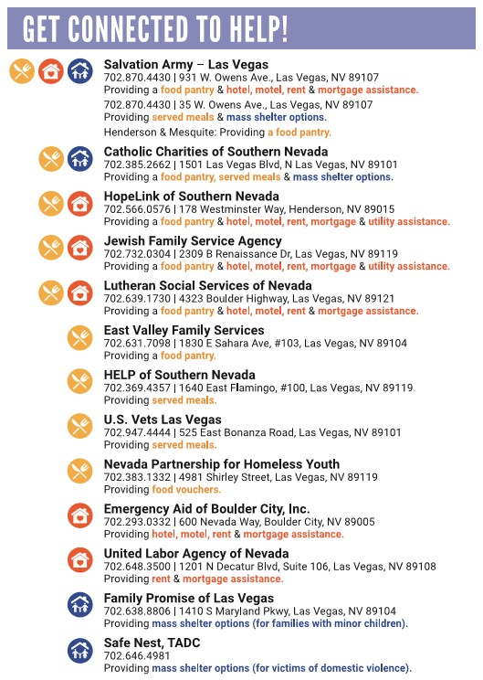

Virtual Volunteer Opportunities
UNLV Volunteerism and the COVID-19 Crisis

UNLV encourages faculty, staff, and students to consider the best ways to help the community during the COVID-19 crisis while following the governor’s directives regarding the pandemic. Philanthropic contributions to area nonprofits are excellent ways to support those most severely affected by this crisis. However, UNLV does not endorse, and strongly recommends against, in-person student and faculty/staff volunteerism at this time. Certain special circumstances, specifically those involving individuals working in the health care and public health disciplines, may allow for exception.

Alternatively, faculty, staff, and students are encouraged to consider utilizing their expertise to volunteer remotely, and the Offices of Community Engagement and Service Learning and Leadership are continuously working to identify and share these types of opportunities.

UNLV strongly recommends that its employees and students abide by this directive when considering how they can help.

Las Vegas Opportunities

CCSD Stay in School Mentoring Program (SISMP) - https://ccsd.net/community/partnership/programs/stay/stay-index/
- The SISMP matches volunteers from the community across a broad spectrum of professions with students that need guidance and support to help them be successful in school. There are also opportunities to record ‘Mentoring Messages,’ brief recorded inspirational messages.
- Contact Akita McCulloch at mcculad@nv.ccsd.net with any questions about the mentoring programs.

Nevada Partnership for Homeless Youth - https://nphy.org/covid19/
- Listed at the bottom of the page are ways to help NPHY remotely, including spreading awareness about their services and building hygiene and sunshine kits for them to distribute. Can purchase donations items online and have them shipped.

Sew Masks - City of Henderson - 702-457-9600
- The City of Henderson is seeking skilled sewists to volunteer to make masks for hospital workers. Call to volunteer.

Support a Senior - https://supportlvseniors.com/
- Support a Senior Las Vegas was established to connect the broader Las Vegas community with our senior population. The COVID-19 pandemic has required many seniors to significantly limit their interaction with others, leaving many socially isolated. Not only does social interaction improve a person’s mental health, but it can also significantly contribute to strengthening their physical well-being and quality of life. In response to this, Support a Senior has set up a system where you can support a senior through socially distanced communication – email, phone calls, Skype, Zoom, FaceTime, etc.
- Community members and seniors who would like to participate can sign up through supportlvseniors.com. After providing background information to ensure senior safety, volunteers will be paired with a senior in the community to check in with weekly or biweekly. We hope that through this program we can not only support our most vulnerable population during this time but also further strengthen our community ties.

United Way of Southern Nevada - https://www.uwsn.org/COVID19
- On the form, indicate interest in virtual volunteer opportunities (#17).
- Examples include virtual feminine hygiene kits, virtual 5k support, etc.

Other Virtual Opportunities

Do Something - www.dosomething.org
- A digital platform to connect young people with volunteer, social change, and civic action campaigns.

Folding@Home - https://foldingathome.org
- Utilize your spare computing power to contribute to disease research.

Good Deeds Day - www.good-deeds-day.org/blog/
- A list of virtual volunteering links.

Help from Home - http://www.helpfromhome.org
- A collection of micro- and virtual volunteering opportunities.

Idealist.org - www.idealist.org
- A platform to connect people and organizations.

Librivox.org - librivox.org
- Free public domain audio books. You can volunteer to read and record a book.

Missingmaps.org - www.missingmaps.org
- An open, collaborative project to help map areas where humanitarian organizations are trying to meet the needs of vulnerable people.

NemoNet - nemonet.info
- A video game produced by NASA in which you travel virtually to the ocean’s depths, identifying and classifying real corals that you encounter. This in turn helps scientists create a better maps of the world’s coral that can help with conservation efforts.

Online volunteering - www.onlinevolunteering.org
- Managed by the United Nations Volunteers; a rich compendium of vetted online volunteering opportunities.

Points of Light - www.pointsoflight.org/resources/virtual-volunteer-opportunities
- A collection of virtual volunteering opportunities.

Quarantine Chat - quarantinechat.com
- Sign up to converse with others in quarantine.

Smithsonian Digital Volunteers - https://transcription.si.edu/about
- Volunteer with the Smithsonian to help meet their transcription needs.

Students Rebuild - www.studentsrebuild.org/challenges/hunger
- An opportunity to learn about the global challenge of hunger, share a favorite personal recipe, and trigger a donation to non-profit organizations working to address this need.

Volunteer Match - www.volunteermatch.org
- Volunteer discovery resource. Includes specific search for online volunteer opportunities.

Zooniverse - www.zooniverse.org
- Support real, cutting edge research virtually.

